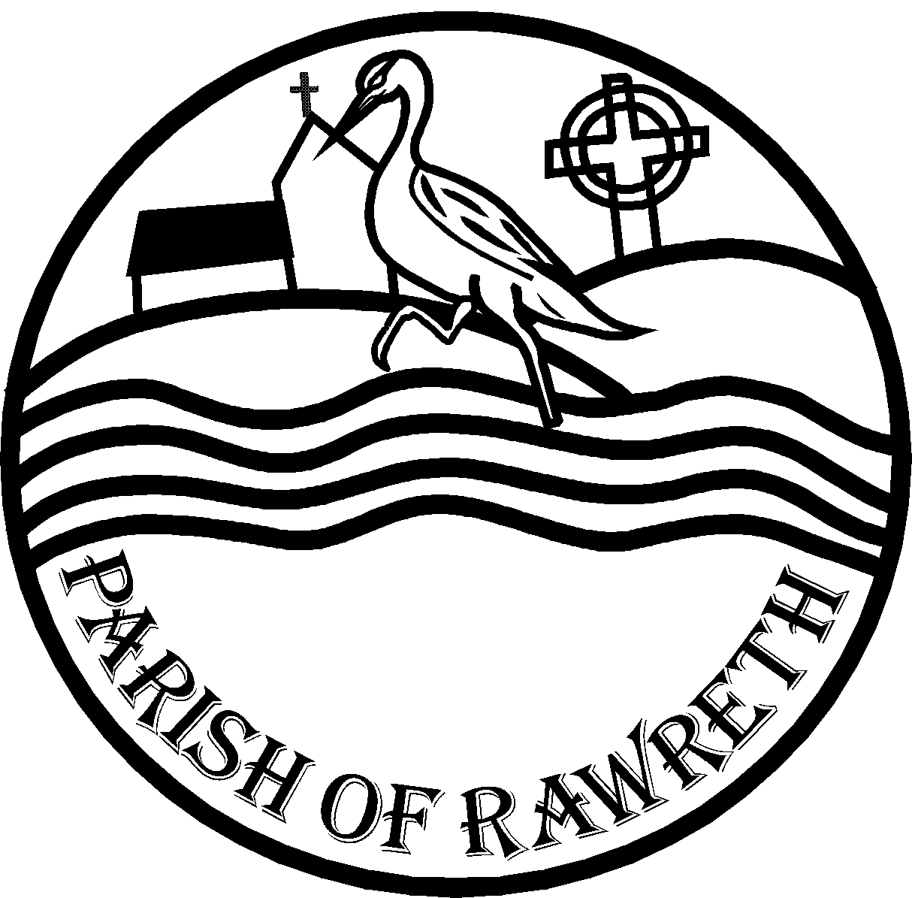

RAWRETH PARISH COUNCIL

Invites you to Rawreth’s 26th
Annual Parish Meeting
To be held in The Village Hall
Church Road Rawreth
8.00 pm on Wednesday 1st June 2022

This is a public meeting where you are invited to meet with your Councillors and discuss the subjects that concern you.

The following matters have so far been placed on the Agenda of the Annual Parish Meeting of Rawreth Parish being held on Wednesday the 1st of June 2022 at 8.00pm

- CHAIRMANS OPENING REMARKS
- APOLOGIES FOR ABSENCE
- APPROVAL OF PREVIOUS MEETING MINUTES 1st May 2019
- PARISH ACCOUNTS FOR THE FINANCIAL YEAR 2021/2022
- OPPPORTUNITY FOR VISITING COUNCILLORS TO ADDRESS THE MEETING
- QUESTIONS FROM THE PUBLIC
Members of the public are requested to direct any specific subjects that they wish to discuss at the Meeting to the Clerk Hayley Bloomfield before the evening of 1st June 2022 either in writing to PO Box 2206 Rayleigh SS6 0DS or by email clerk@rawrethparishcouncil.co.uk

