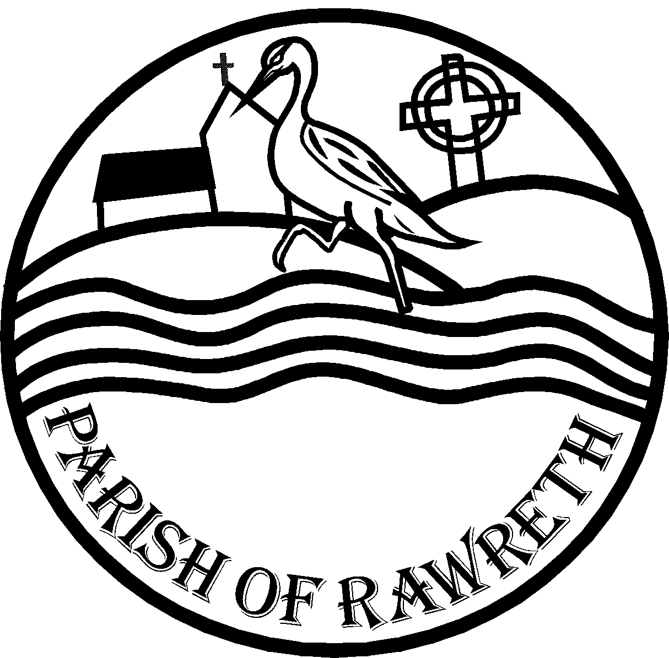RAWRETH PARISH COUNCIL
FREEDOM OF INFORMATION POLICY

Rawreth Parish Council, like all other public authorities, is subject to the Freedom of Information Act 2000 (“the Act”). The Act aims to make information held by the public authorities more accessible to the public and allows individuals and companies to request a wide variety of material.
Your rights under the Act.
On receipt of a request for information the Council must:
- Inform you in writing whether it holds the information requested and , if so,

- Communicate that information to you.

The Council is not required to comply with these obligations where exemptions apply.
Who may request information?
Any Individual or company may make a request. The Council does not need to know why you are making the request or what you intend to do with the information. It will not impose conditions on the use or further disclosure of information provided, although information disclosed may be subject to copyright protection.
What information may I request?
You may request any information held by or on behalf of the Council and recorded in any form. This includes paper records (including handwritten notes), information held on computers, other electronically held information (audio and video recordings), plans, maps and photographs.
You are entitled to the information contained in documents, not the documents themselves. However, where appropriate and convenient the Council may choose to provide a copy of the document rather than extracting information from it. There may be a charge for extracting or providing copies of this information (see below)
If you request “personal information” covered by the General Data Protection Regulations or “environmental information” covered by the Environmental Information Regulations 2004 then different rules apply.

How do I make a request?
Requests must be made in writing and should include:
- your name and address (physical or electronic) for correspondence;
- a clear statement of the information you are requesting;
- a contact telephone number in case the Parish Clerk need to discuss your request;
- the form in which you wish to receive your information.
Requests may be submitted via letter or email to the Council at clerk@rawrethparishcouncil.co.uk or Rawreth Parish Council PO Box 2206 Rayleigh Essex SS6 0DS
What the Council do when it receives your request?
The Council will acknowledge your request and let you know if all or part of your request will be dealt with under the Environmental Information Regulations/the General Data Protection Regulations. The Parish Clerk will let you know if they require further information in order to identify and locate the information you have requested.
If the Council does not hold the information requested, it will consider whether it may be appropriate to transfer your request to another public authority.
How long does it take?
The Councils is obliged to comply with the obligations under the Act promptly and (subject to limited exceptions) within 30 working days following the date it receives your request. If the Parish Clerk needs to ask you for clarification of the request, the 30 working days period does not start until it is received. If payment is required, the 30 working day period restarts on receipt of the payment.
If (in limited circumstances where the Council is permitted to do so) it needs to extend the timescale to give proper consideration to the request, then the Parish Clerk will inform you of this.
Already published information.
The Council routinely handles requests for basic information and will continue to do this without necessarily having to treat the request as a request under the Act.
The Council also publishes information pro-actively whenever possible, rather than it only being available on request. The Council’s Publication Scheme specifies the categories of information that it publishes or intends to publish, how to obtain that information and whether any payment is required.
If information is available under the Publication Scheme the Council is not obliged to provide the information to you under the Act because it is deemed to be already reasonably accessible to you. Where this is applicable, the Council will respond to your request by explaining how you can access the information.
There are circumstances in which the Council’s obligations under the at will not apply, the Council is not obliged to comply with repeated or vexatious requests nor with requests that exceed the cost limit (see below)
Furthermore, the Act contains a number of exemptions from these obligations, most of which involve the application of a public interest test. If your request is refused, our reply will identify which exemption (or exemptions) the Council is relying on. Where applicable, the Council will explain why it has decided that the public interest in withholding the information (or neither confirming or denying that it holds it) outweighs the public interest in disclosing (or confirming/denying).
Consultation with third parties
If your request relates to a person/company other than yourself and the Council or where disclosure of the information you are requesting could affect the interest of another person, the Council may need to consult that third party before responding to your request.
How is information released?
If you express a preference for receiving the information requested in a particular format or as a summary, the Council is obliged to accommodate your preference unless it is not reasonably practicable for us to do so, Information may be provided in Braille or audio format, in large type or translated into another language. When requesting information be in a particular format or as a summary you should take into account the extra cost of supplying the information in this way.
If you preference is to inspect the records containing the information, this can be arranged under supervision.
When making your request for information, please identify how you would like to receive the information.
What does it cost?
The Act makes provision for a fee to be charged for information.
If the request will cost more than £450.00 to respond to a request, then the Council need not comply with it. The cost limit covers the time taken to find, sort, edit or reformat material (calculated at £25 per hour) it does not cover the time taken to consider whether exemptions apply.
On receipt of your written request the Parish Clerk will write to advise you of the cost of providing the information, in accordance with Rawreth Parish Council’s Model Publication Scheme. The 30 day period will restart from the day the Responsible Financial Officer receives your payment.
Please note that the Council does not have to provide the information if you fail to pay within three months.
Complaints and Appeals
Should you be unhappy with the outcome of a request under the Act, you should in the first instance contact the Clerk. A review of your complaint will take place and the Clerk will reconsider any decisions relating to the release or withholding of information and, if appropriate, provide a further response. If, after review, the original response is considered correct, your complaint will be reconsidered by the Council.
If you are dissatisfied with the results of the Council’s internal review, you may appeal to the Information Commissioner (refer to www.informationcommissioner.gov.uk) for details.

Policy Adopted by Rawreth Parish Council………3rd April 2024

